**PROJECT**

**Chat Application**

**GROUP: 1**

**Nguyễn Lê Tài Đức**

**Lê Bá Thịnh**

**Tô Cao Kim Ngân**

**Trần Minh Nhựt**

Table of Contents

**I.** **Architecture Diagram** 3

**II.** **Subsystem Diagram** 4

1. **High Level** 4

2. **Identity** 4

3. **Conversation** 4

4. **Upload** 5

5. **Post** 6

**III.** **Class Diagram** 7

1. **Identity** 7

**i.** **Accept Friend Request** 7

**ii.** **Block User** 7

**iii.** **Delete Friend** 8

**iv.** **Delete Friend Request** 9

**v.** **Get Friend List By User Id** 10

**vi.** **Get Friend Request List** 11

**vii.** **Get User By Id** 12

**viii.** **Login** 13

**ix.** **Register** 14

**x.** **Search User** 14

**xi.** **Send Friend Request** 14

**xii.** **Unblock User** 15

**xiii.** **Update User** 16

2. **Conversation** 16

**i.** **Create Group Conversation** 17

**ii.** **Delete Conversation** 17

**iii.** **Get All** 17

**iv.** **Get By Id** 18

**v.** **Get Conversation** 18

**vi.** **Get Conversation List By User Id** 19

**vii.** **Get Member List By Conversation Id** 19

**viii.** **Group Add User** 20

**ix.** **Group Block User** 20

**x.** **Group Disband** 21

**xi.** **Send Client Message** 21

**xii.** **Update Group Conversation** 22

**xiii.** **User Exit Group** 22

**xiv.** **User Join Group** 22

3. **Post** 23

**i.** **Create Post** 23

**ii.** **Create Post Interaction** 23

**iii.** **Create Report Post** 24

**iv.** **Get All Post** 24

**v.** **Get All Report Post** 25

**vi.** **Get Post By Id** 25

**vii.** **Get By User Id** 26

**viii.** **Get Post Interaction** 26

**ix.** **Get Report Post By Post Id** 27

**x.** **Uninteraction Post** 28

**xi.** **Update Post** 28

**xii.** **Create Comment** 28

**xiii.** **Get Comment By Post Id** 29

**xiv.** **Update Comment** 29

**xv.** **Create Interaction** 30

**xvi.** **Delete Interaction** 30

**xvii.** **Get All Interaction** 30

**xviii.** **Update Interaction** 31

**xix.** **Create Tag** 31

**xx.** **Delete Tag** 32

**xxi.** **Get All Tag** 32

**xxii.** **Update Tag** 32

**IV.** **Database diagram** 33

1. **File Db** 33

2. **IdentityDB** 33

3. **MessageDB** 34

4. **PostDB** 35

1. **Architecture Diagram**

- Independent deployment and scaling: Each feature can be deployed and scaled separately.

- Enhanced fault isolation: Failures in one service don't impact others.

- Technology diversity: Various languages for each component.

- Streamlined development and maintenance: Teams can work on individual services independently.

- Faster innovation: Enables quicker updates and new feature implementations.

- Higher availability and reliability: Ensures a more resilient and stable application.

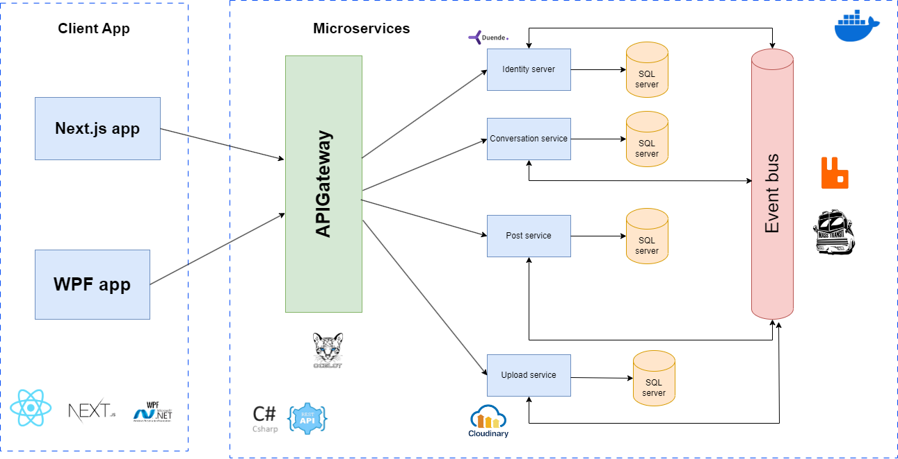

1. **Subsystem Diagram**
   1. **High Level**

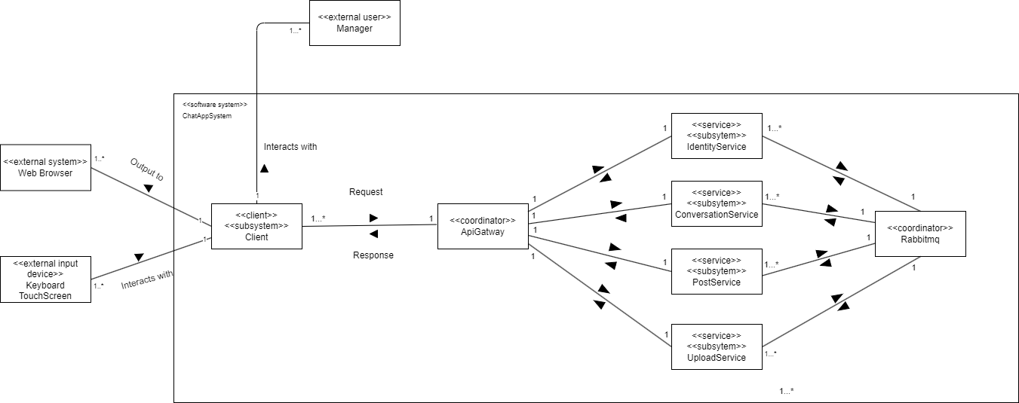

* 1. **Identity**

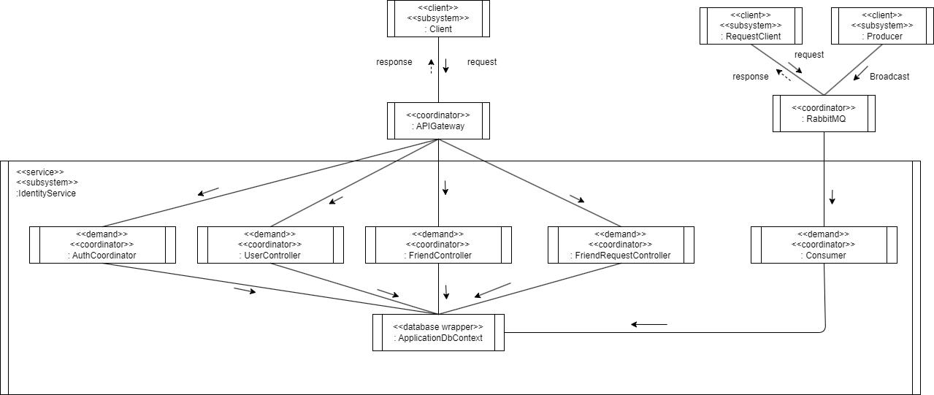

* 1. **Conversation**

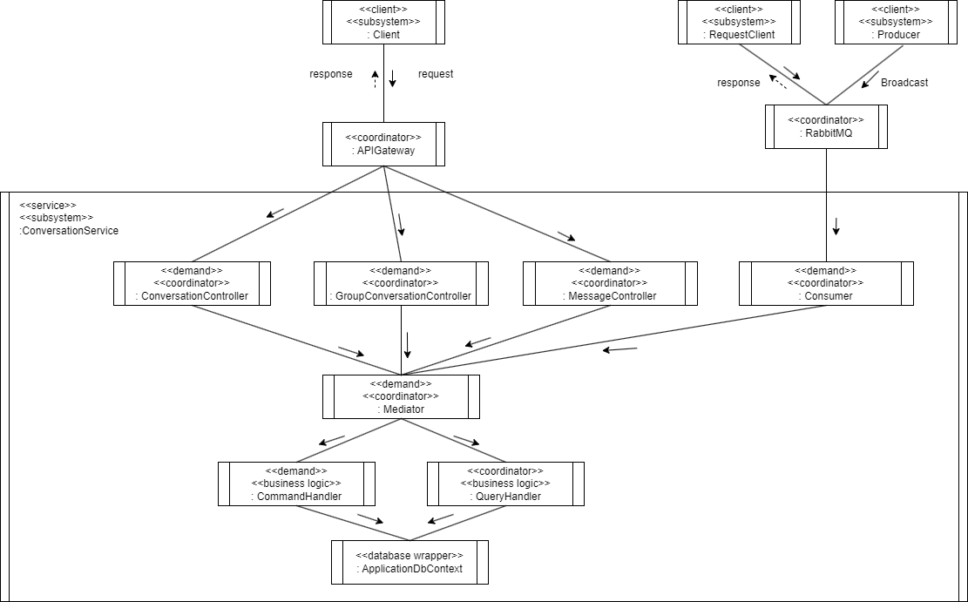

* 1. **Upload**

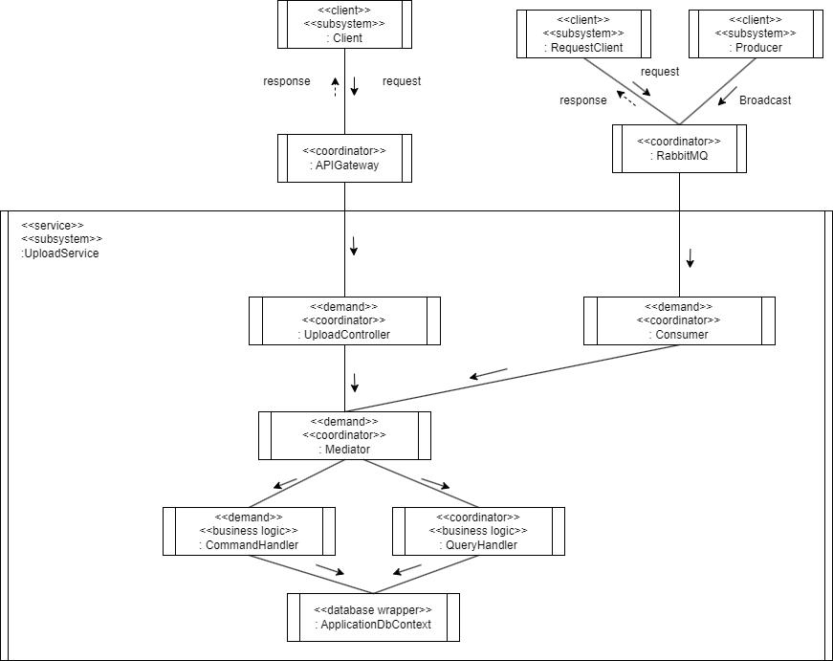

* 1. **Post**

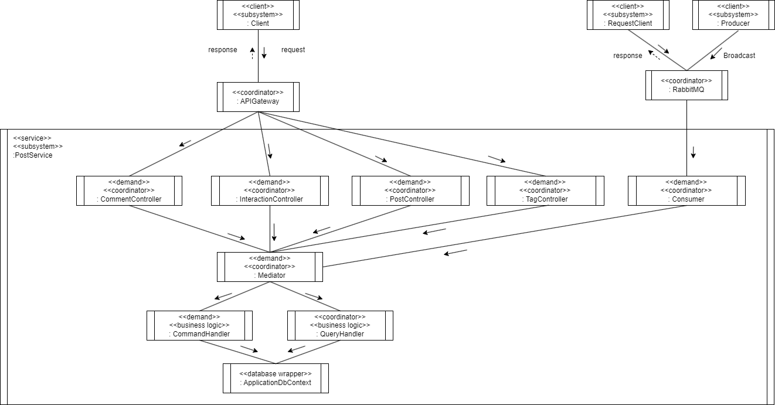

1. **Class Diagram**
   1. **Identity**
      1. **Accept Friend Request**

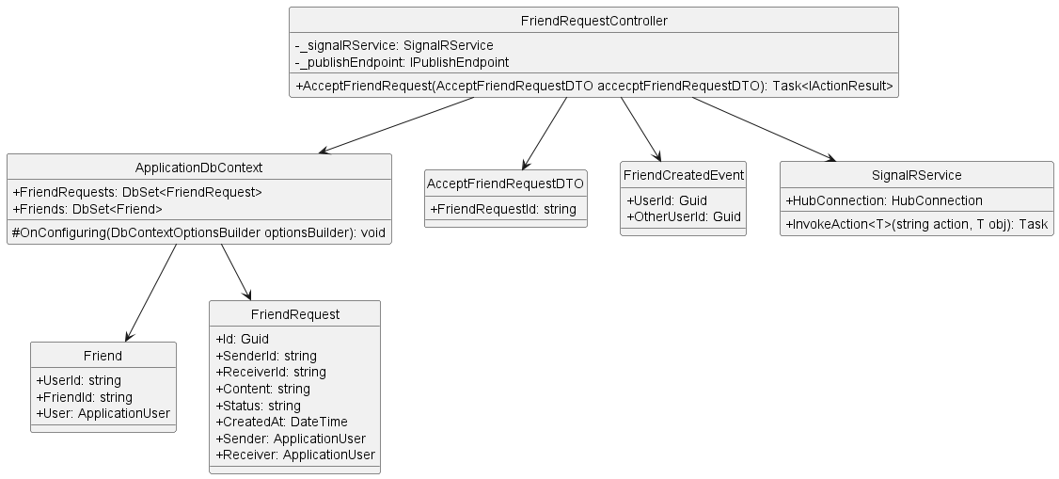

* + 1. **Block User**

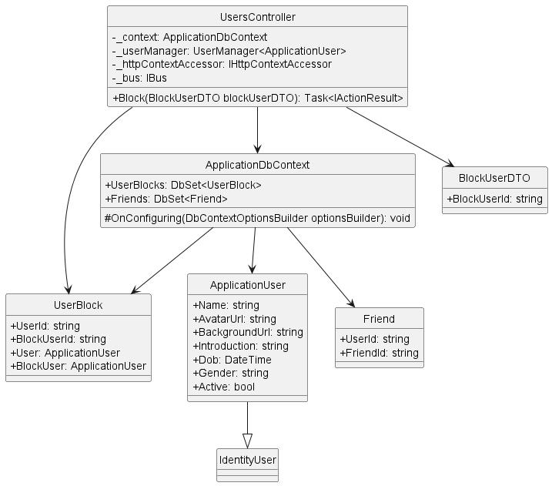

* + 1. **Delete Friend**

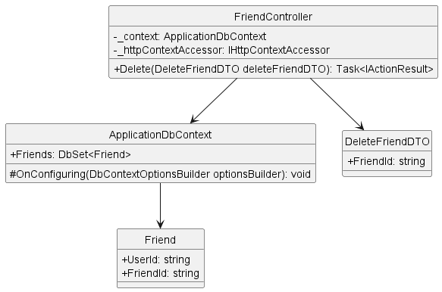

* + 1. **Delete Friend Request**

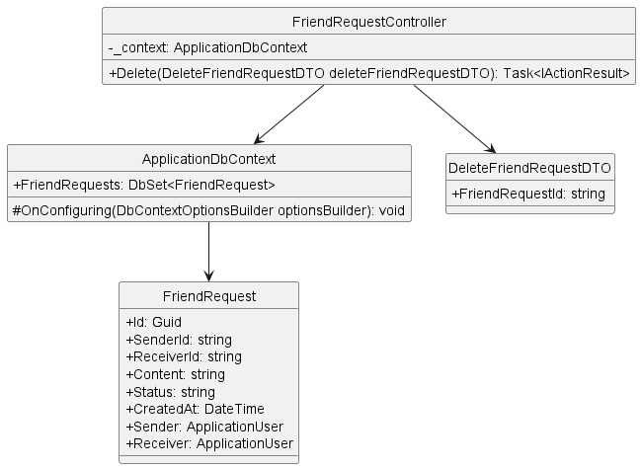

* + 1. **Get Friend List By User Id**

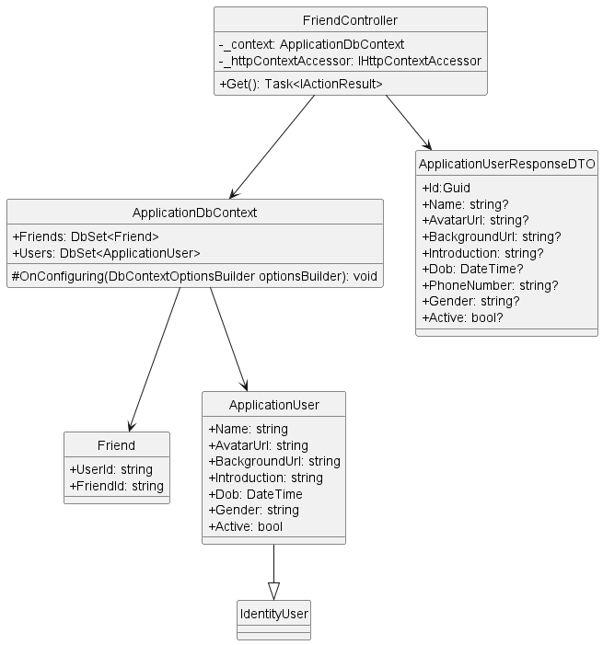

* + 1. **Get Friend Request List**

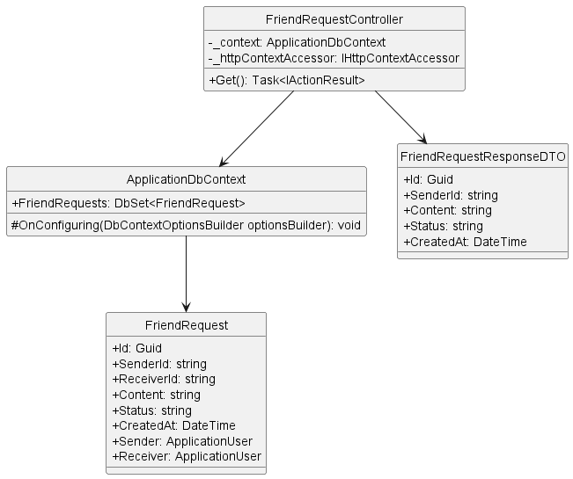

* + 1. **Get User By Id**

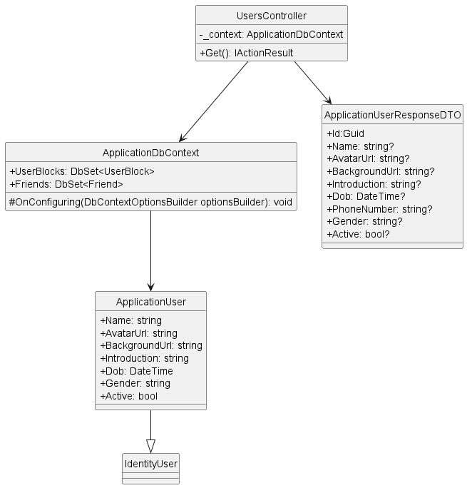

* + 1. **Login**

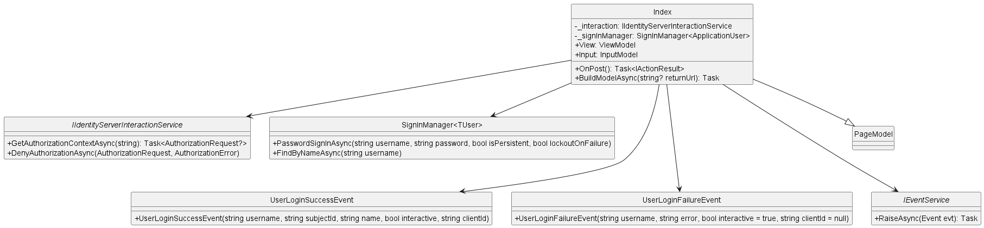

* + 1. **Register**

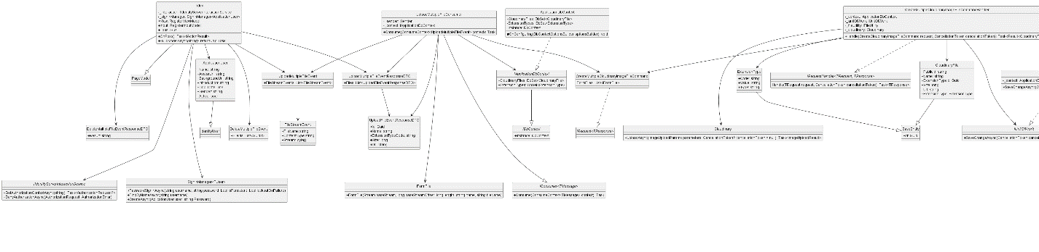

* + 1. **Search User**

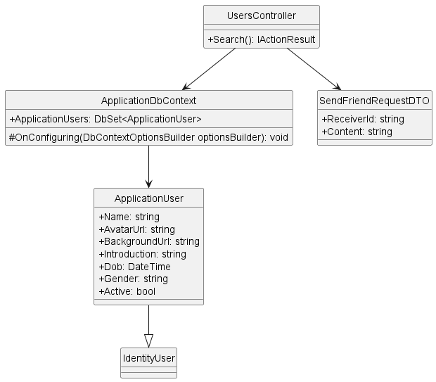

* + 1. **Send Friend Request**

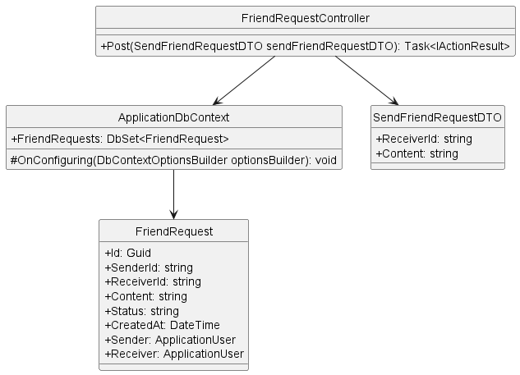

* + 1. **Unblock User**

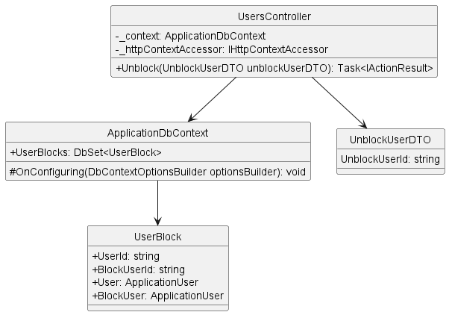

* + 1. **Update User**

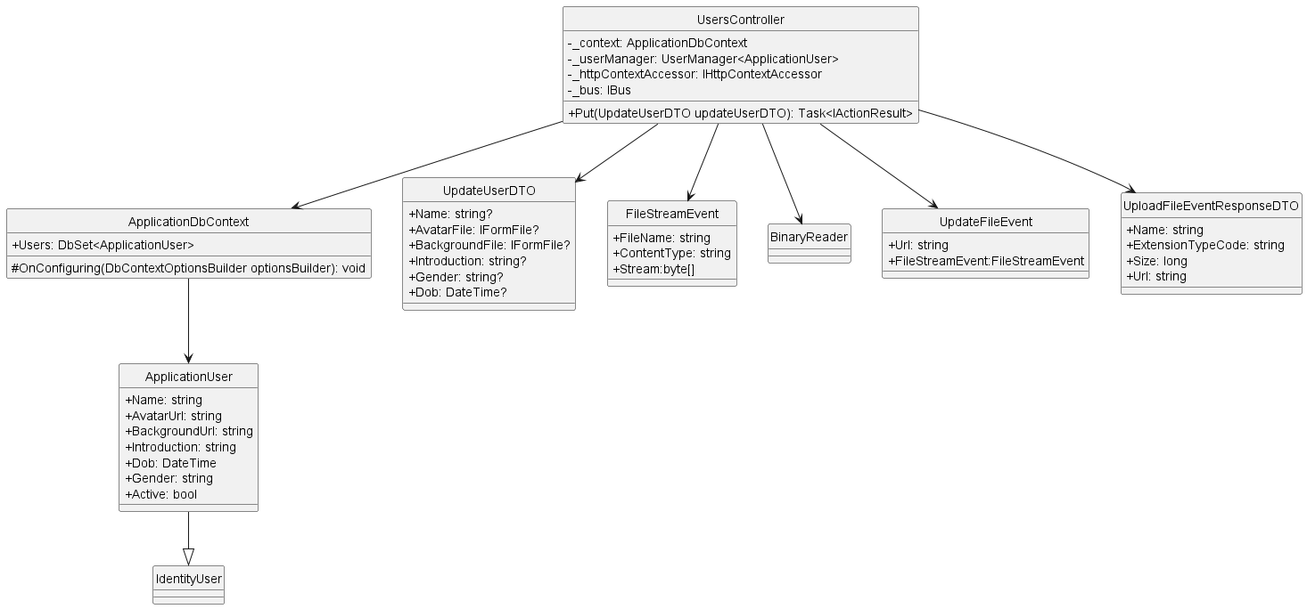

* 1. **Conversation**
     1. **Create Group Conversation**

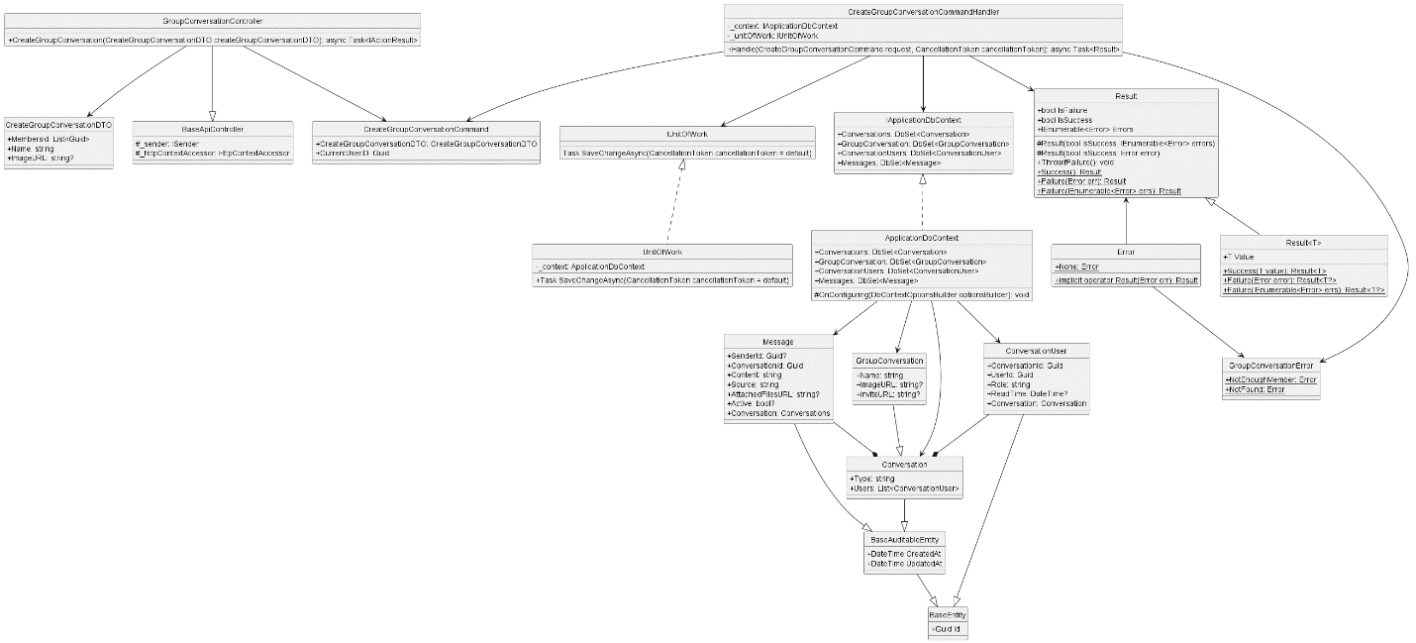

* + 1. **Delete Conversation**

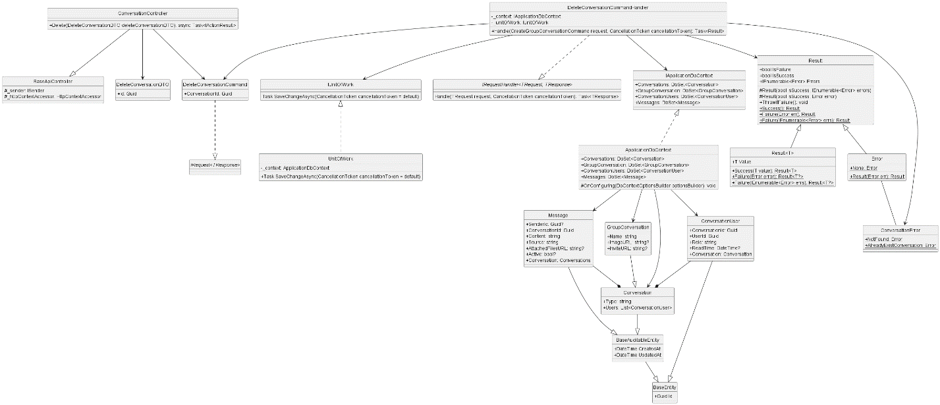

* + 1. **Get All**

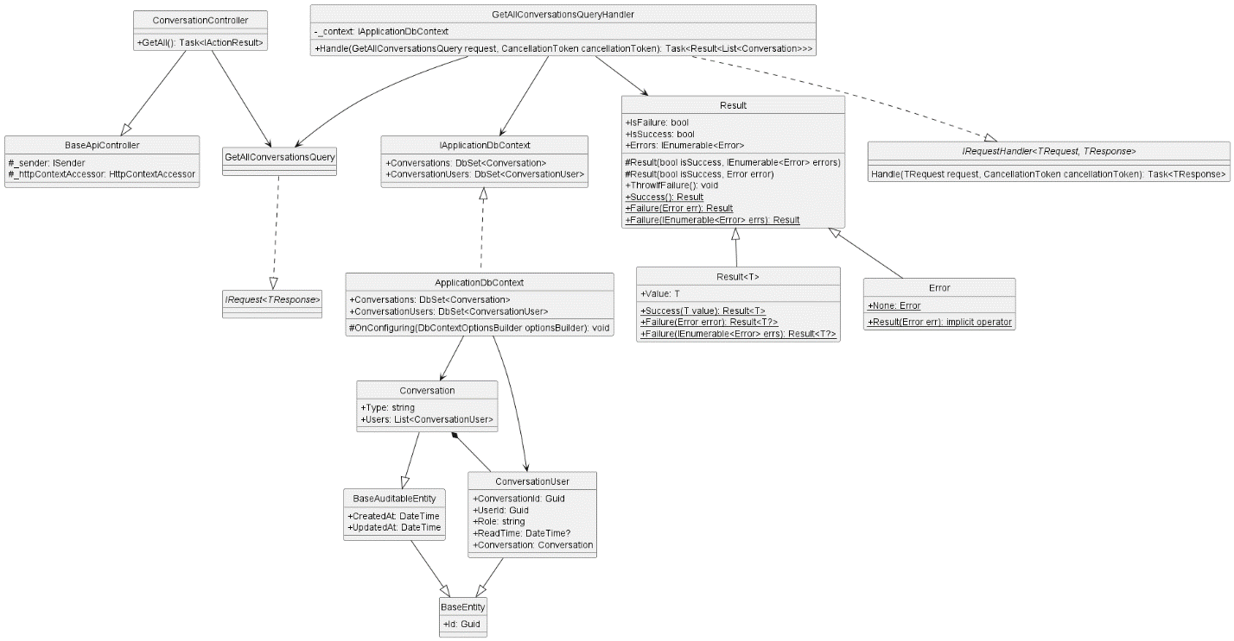

* + 1. **Get By Id**

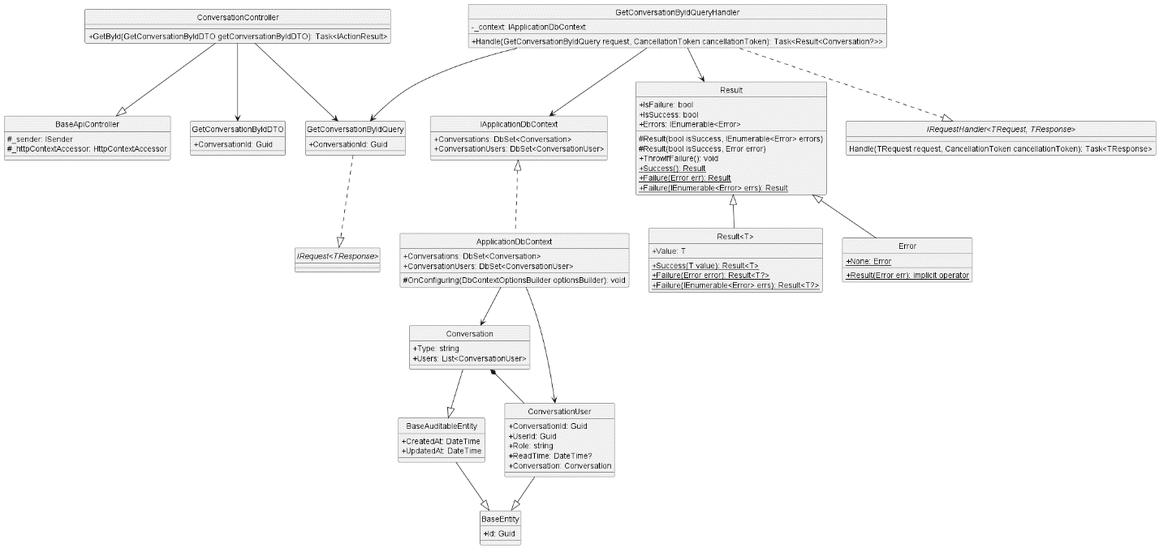

* + 1. **Get Conversation**

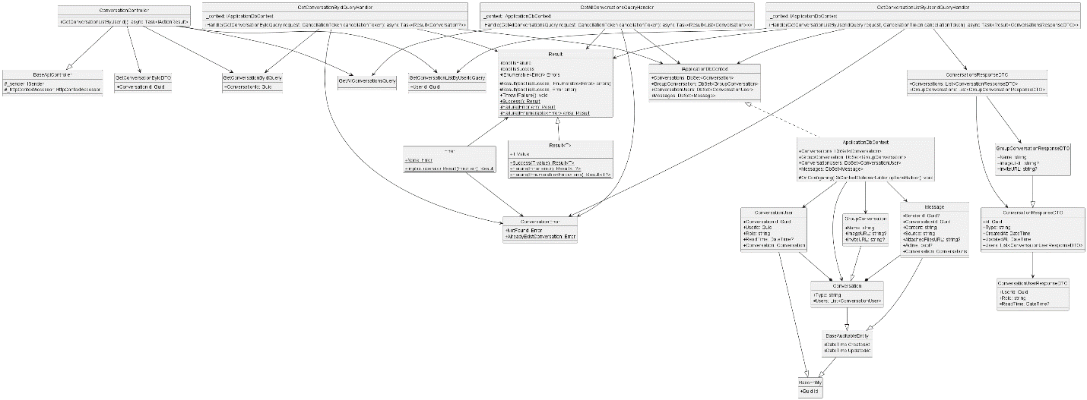

* + 1. **Get Conversation List By User Id**

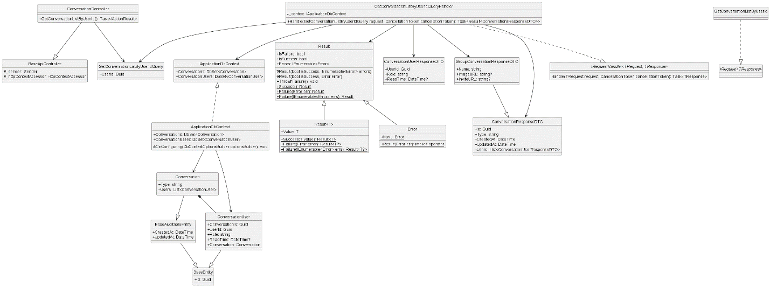

* + 1. **Get Member List By Conversation Id**

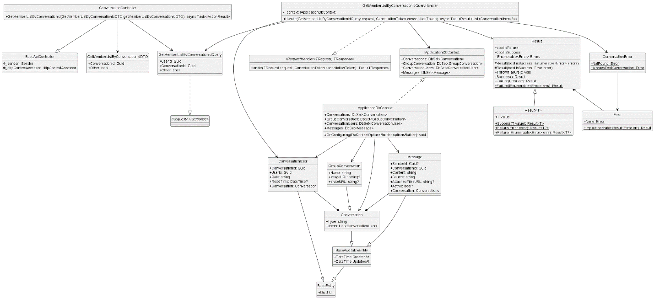

* + 1. **Group Add User**

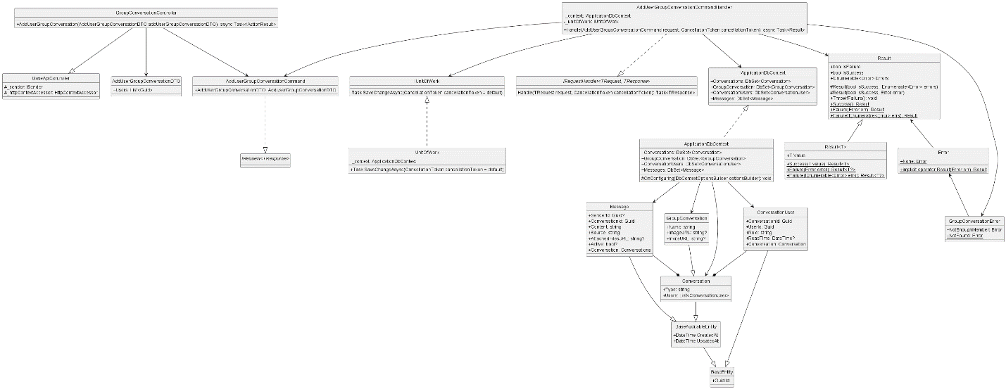

* + 1. **Group Block User**

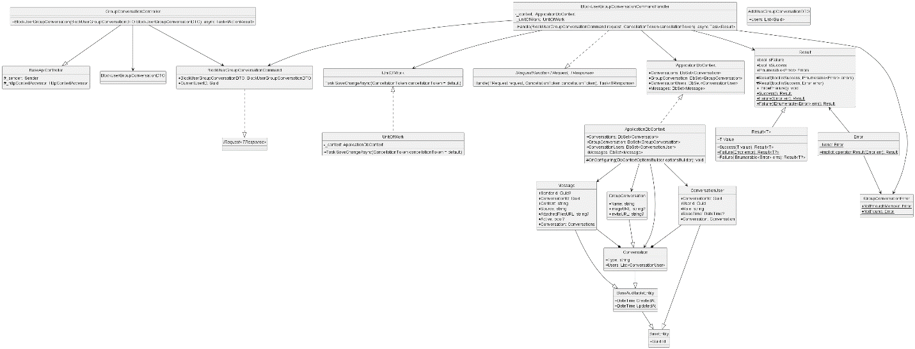

* + 1. **Group Disband**

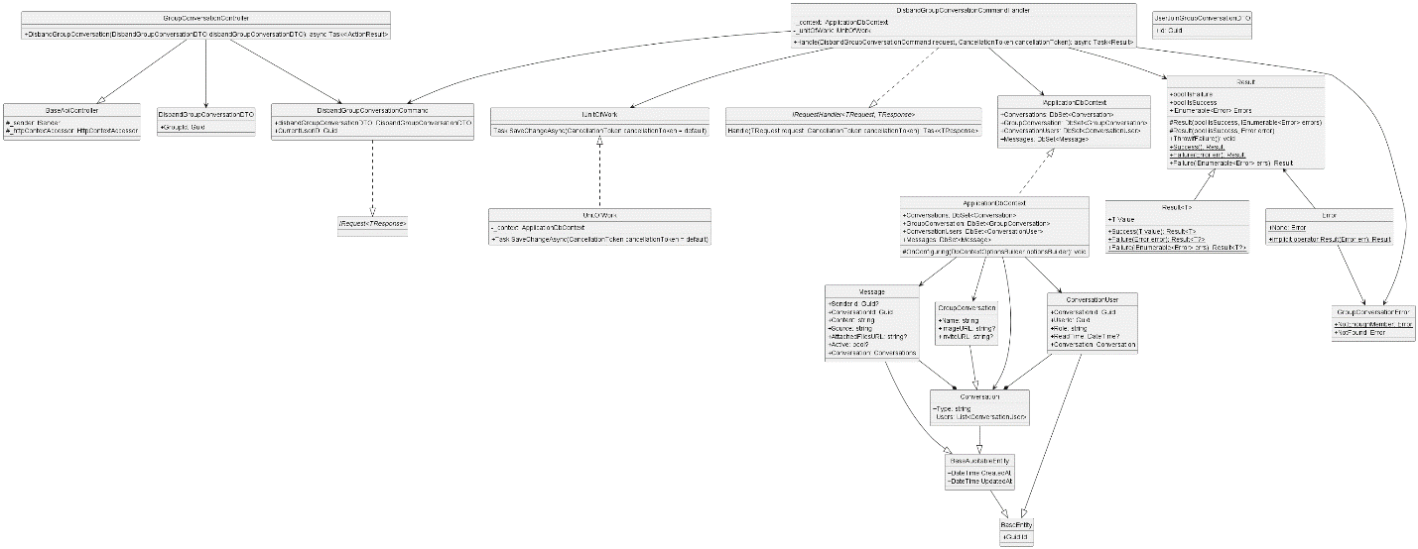

* + 1. **Send Client Message**

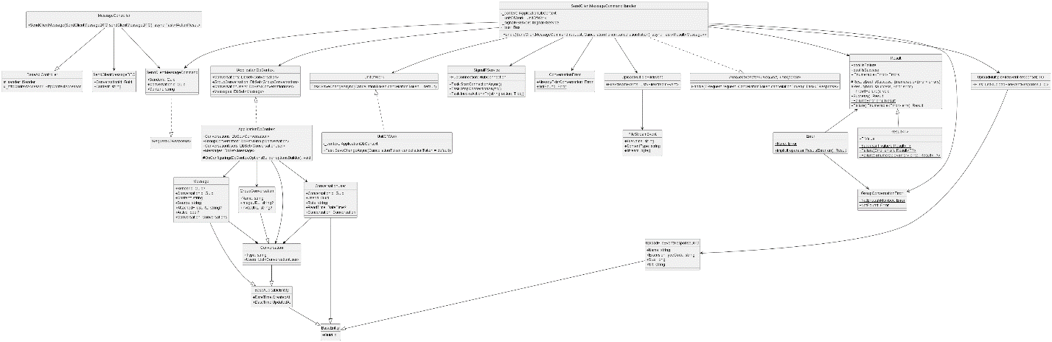

* + 1. **Update Group Conversation**

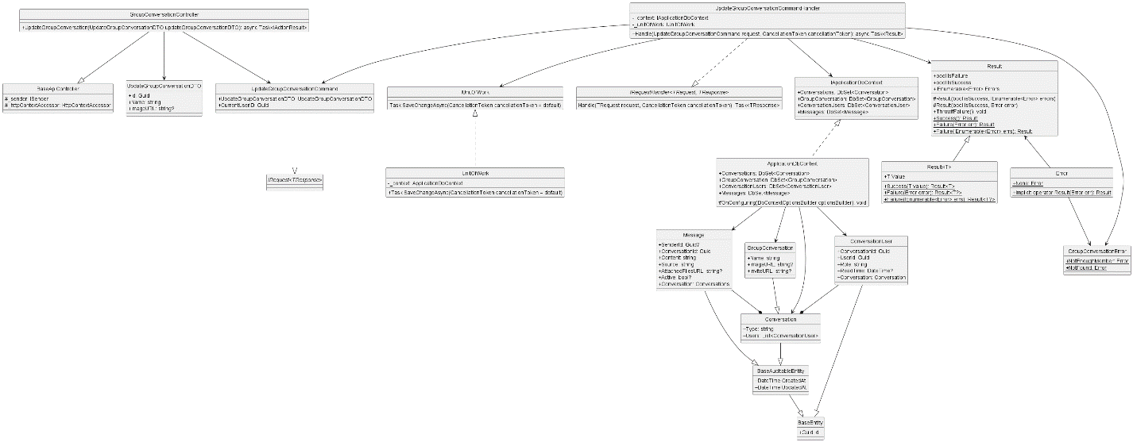

* + 1. **User Exit Group**

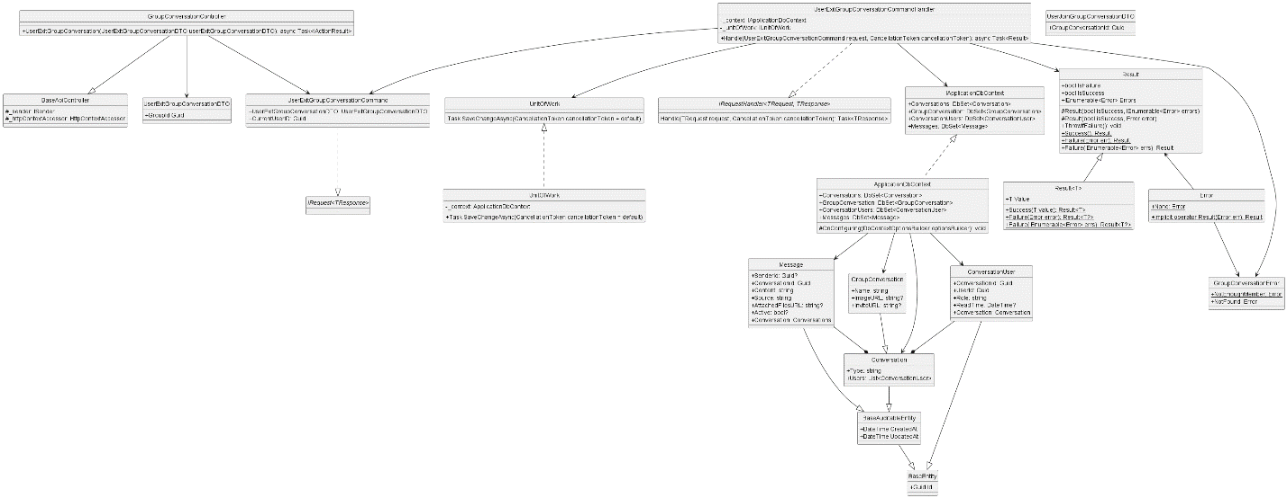

* + 1. **User Join Group**

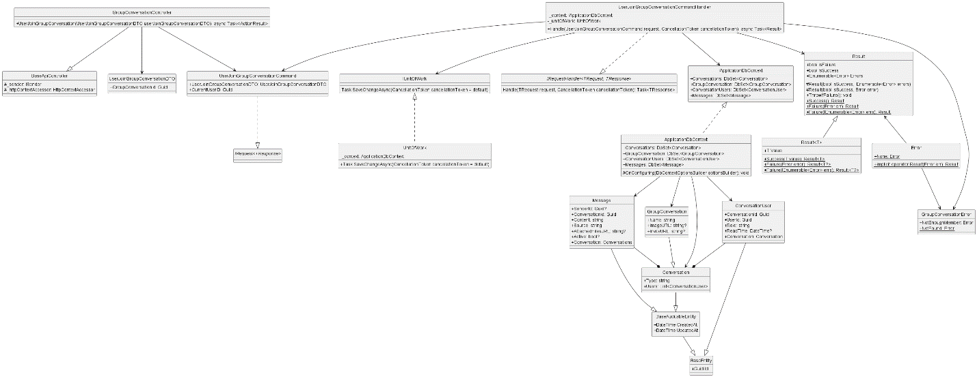

* 1. **Post**
     1. **Create Post**

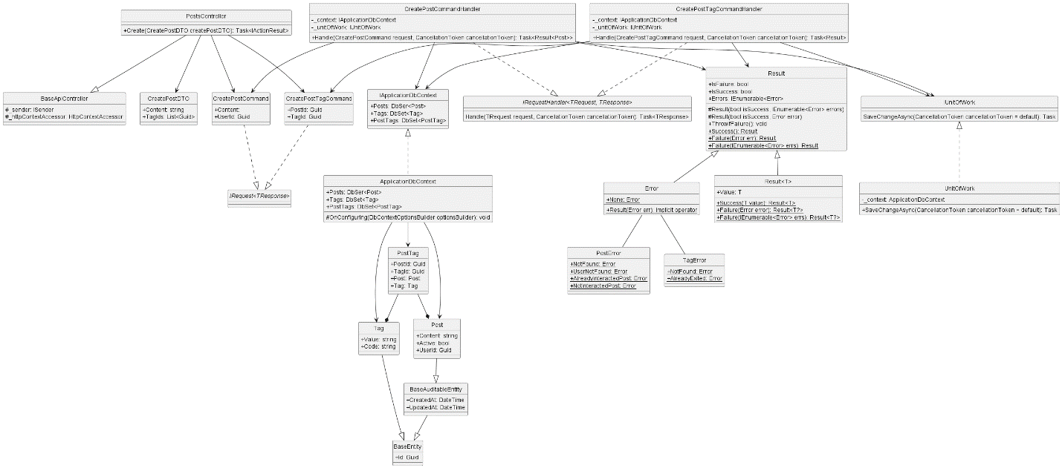

* + 1. **Create Post Interaction**

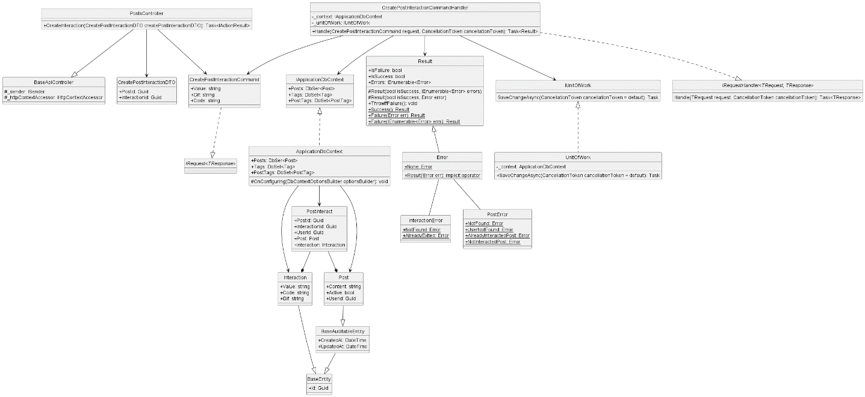

* + 1. **Create Report Post**

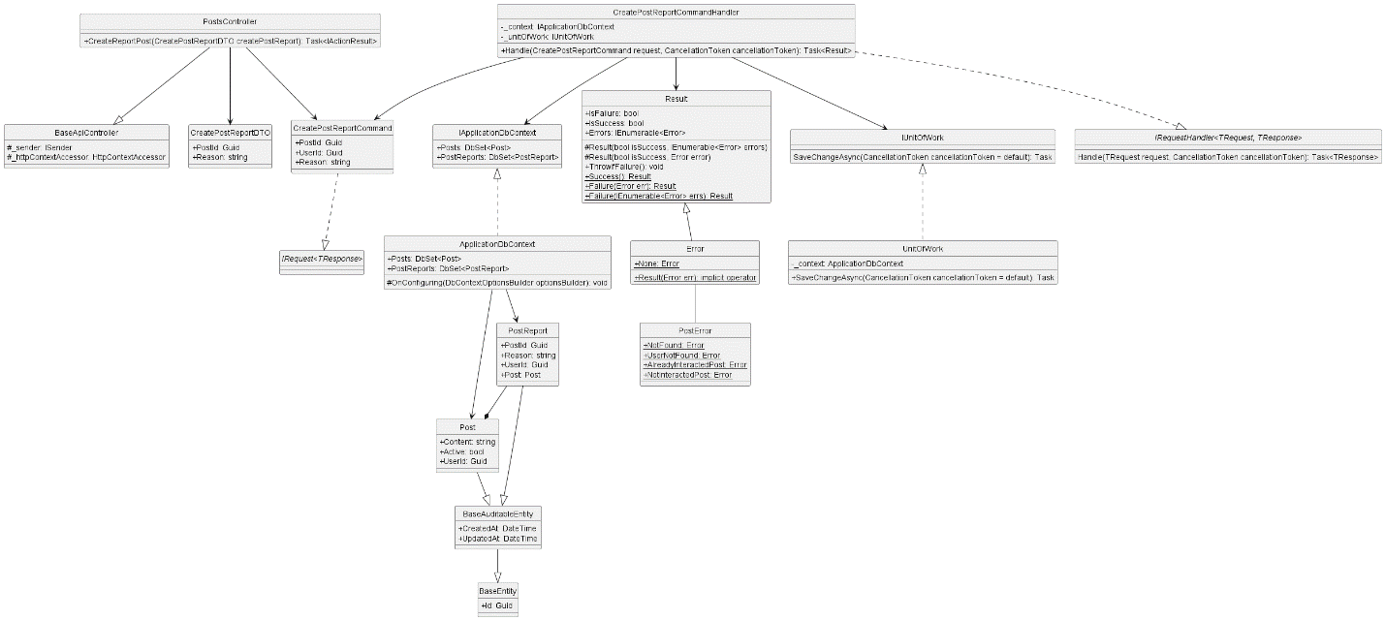

* + 1. **Get All Post**

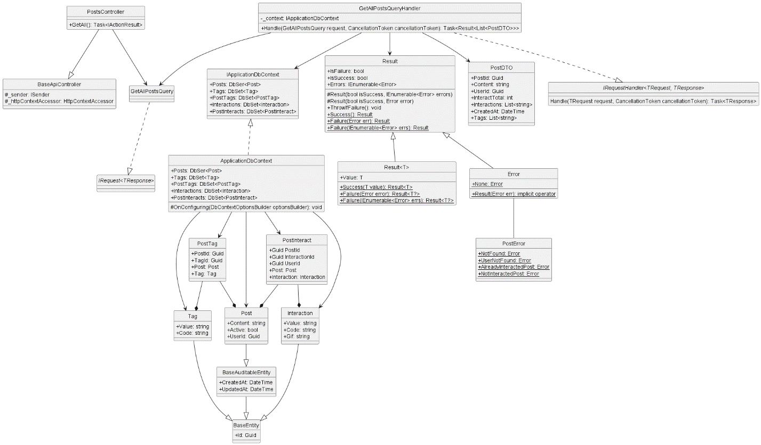

* + 1. **Get All Report Post**

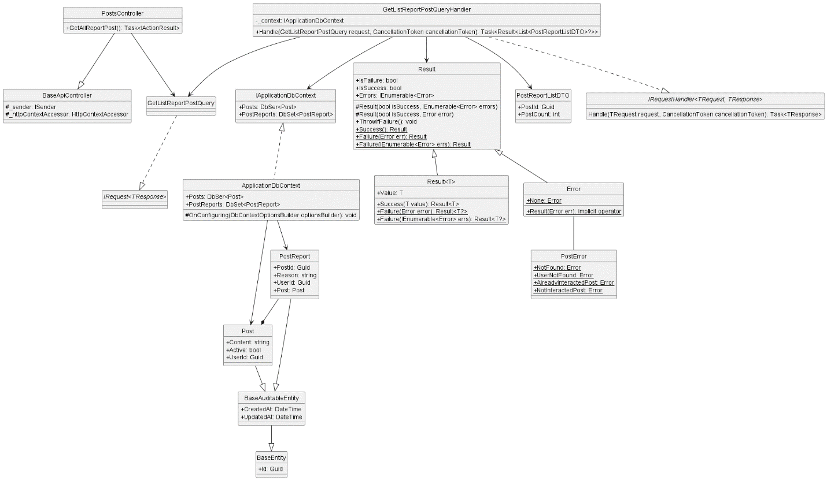

* + 1. **Get Post By Id**

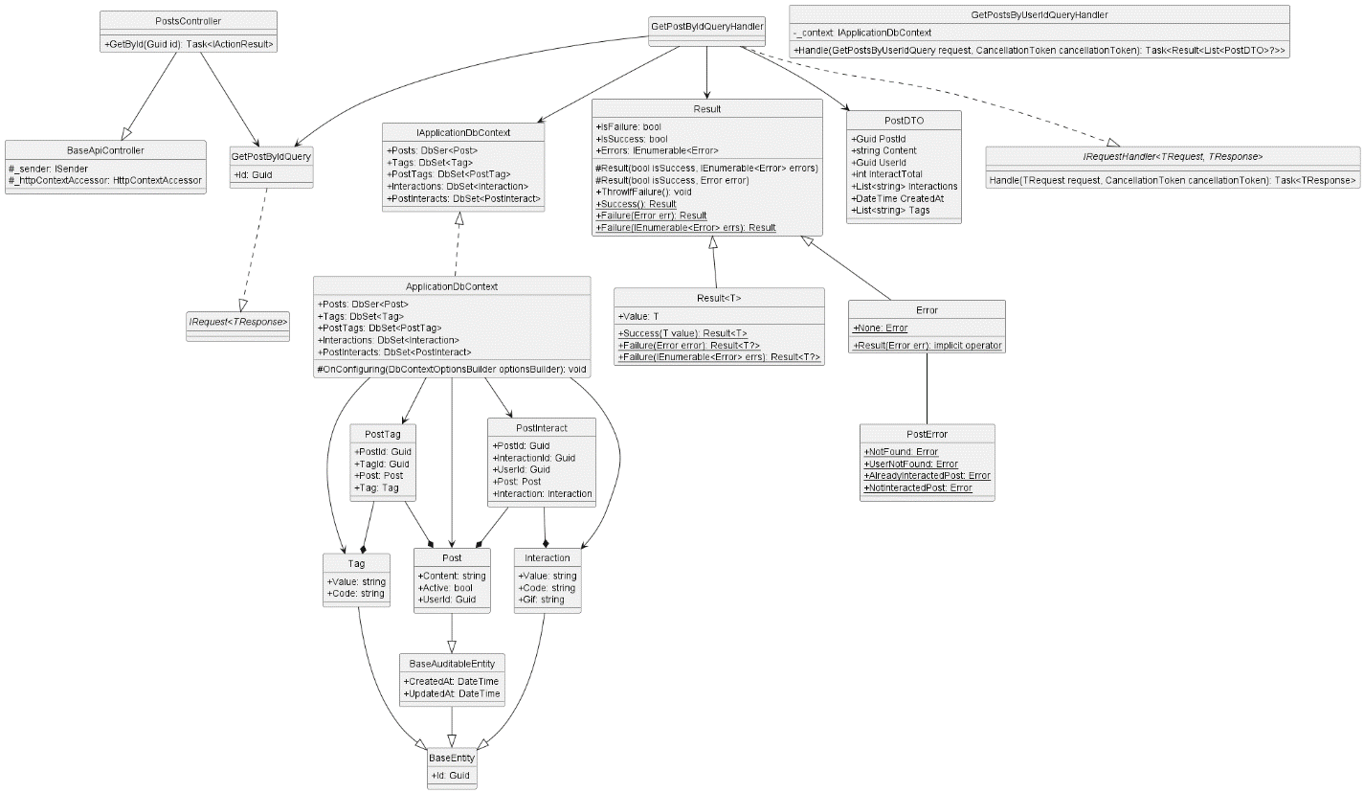

* + 1. **Get By User Id**

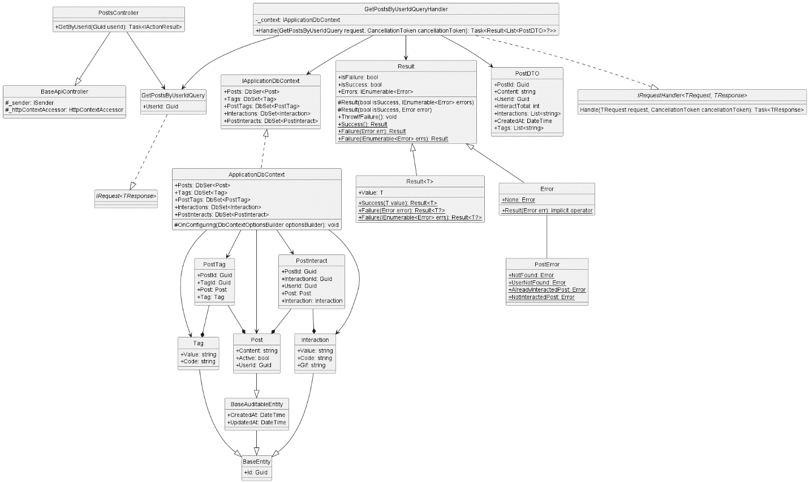

* + 1. **Get Post Interaction**

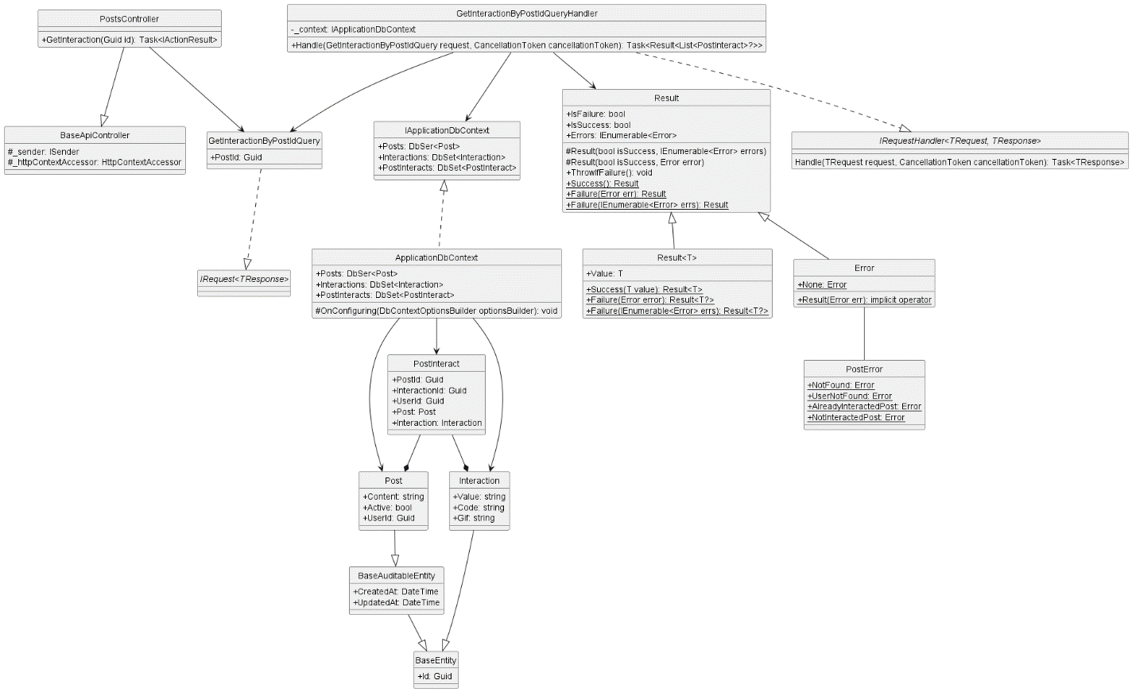

* + 1. **Get Report Post By Post Id**

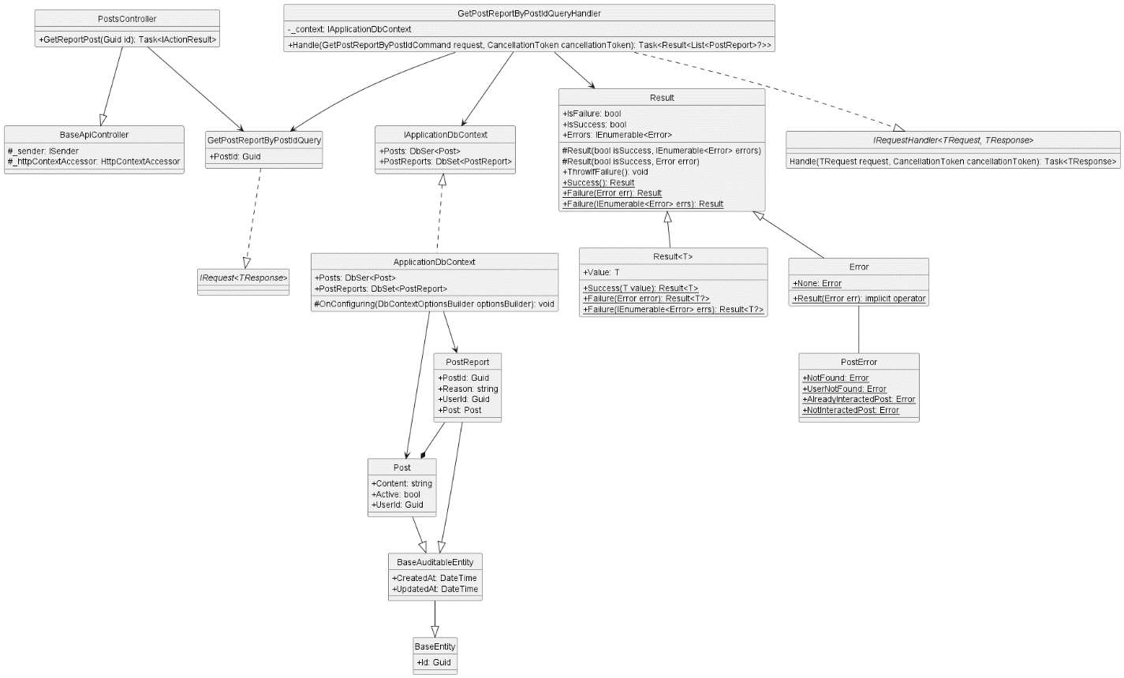

* + 1. **Uninteraction Post**

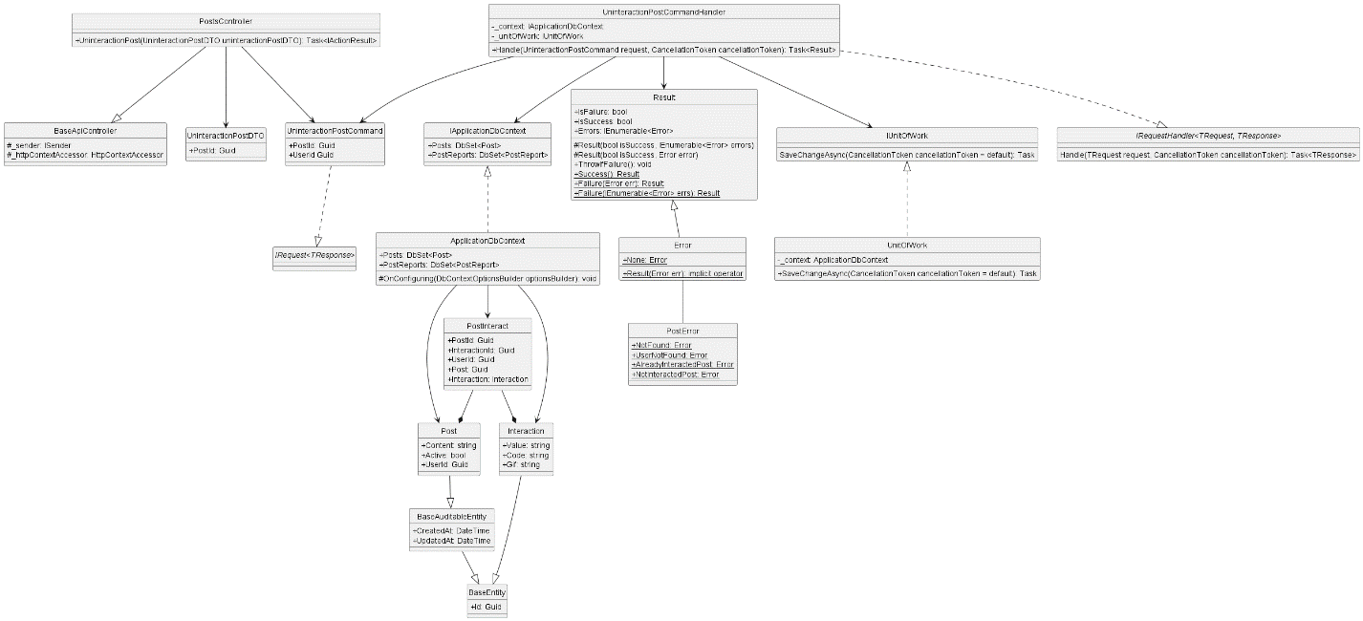

* + 1. **Update Post**

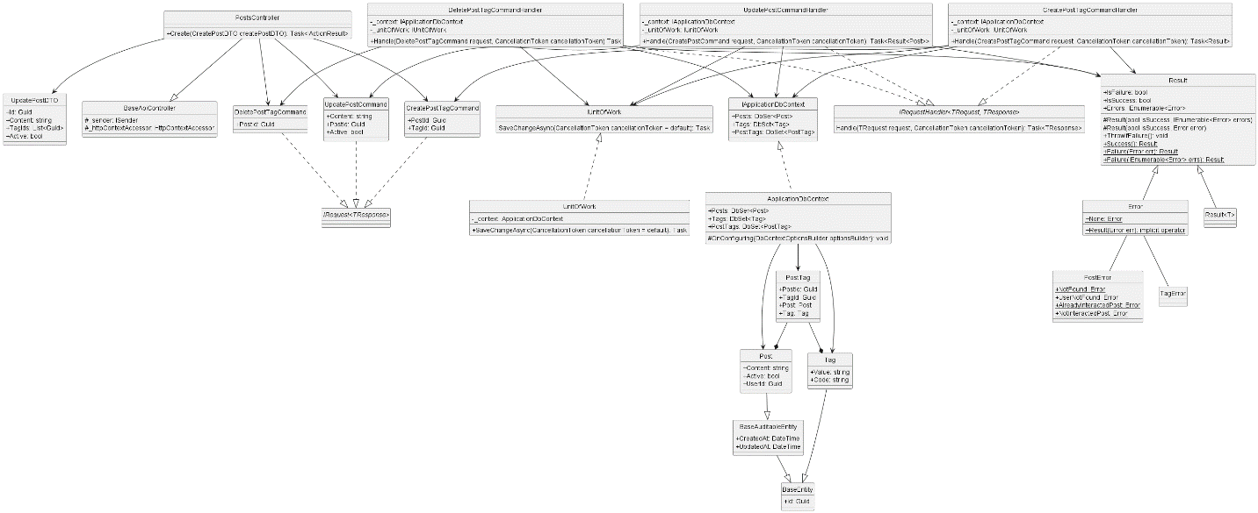

* + 1. **Create Comment**

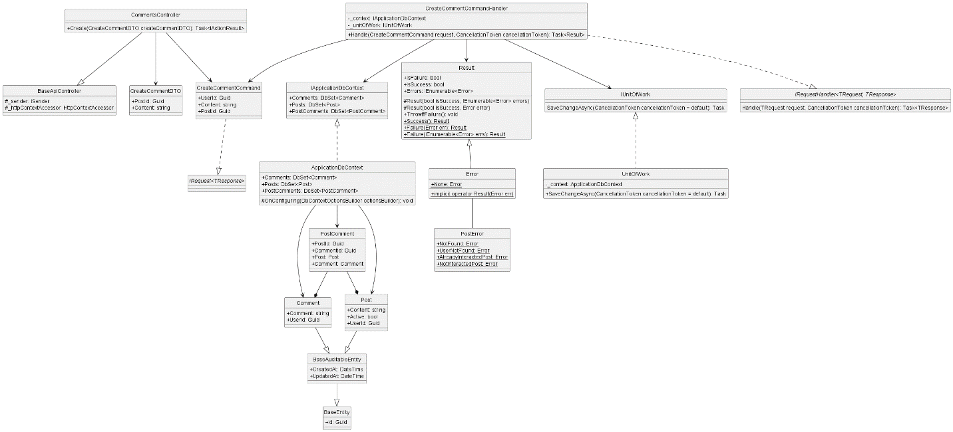

* + 1. **Get Comment By Post Id**

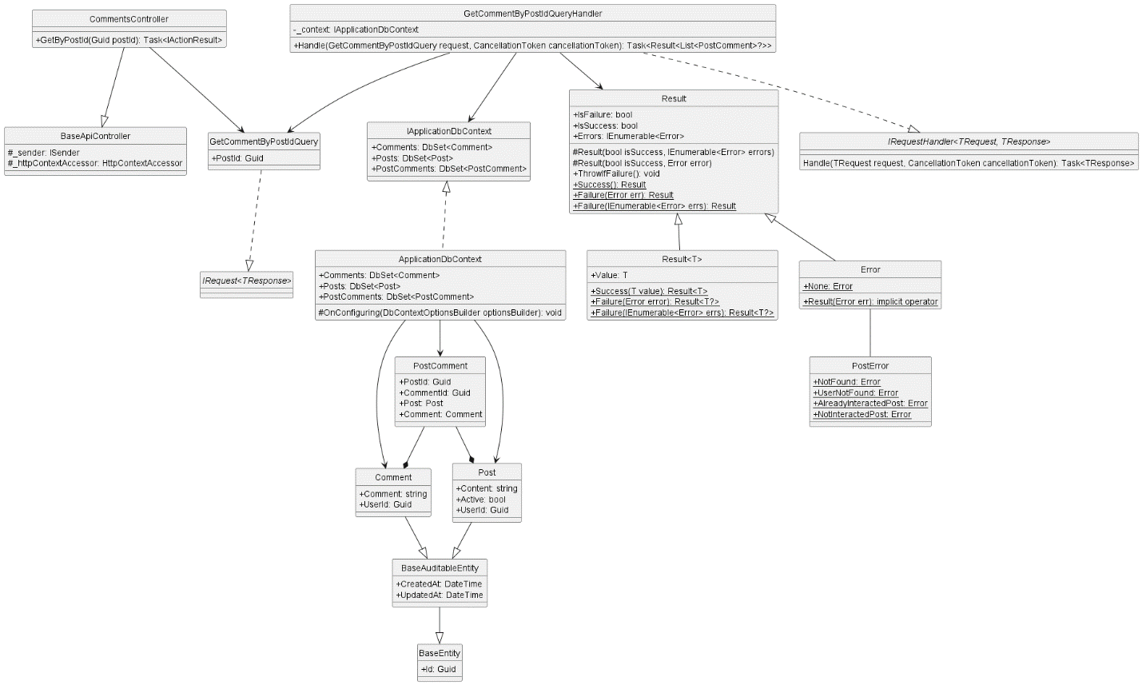

* + 1. **Update Comment**

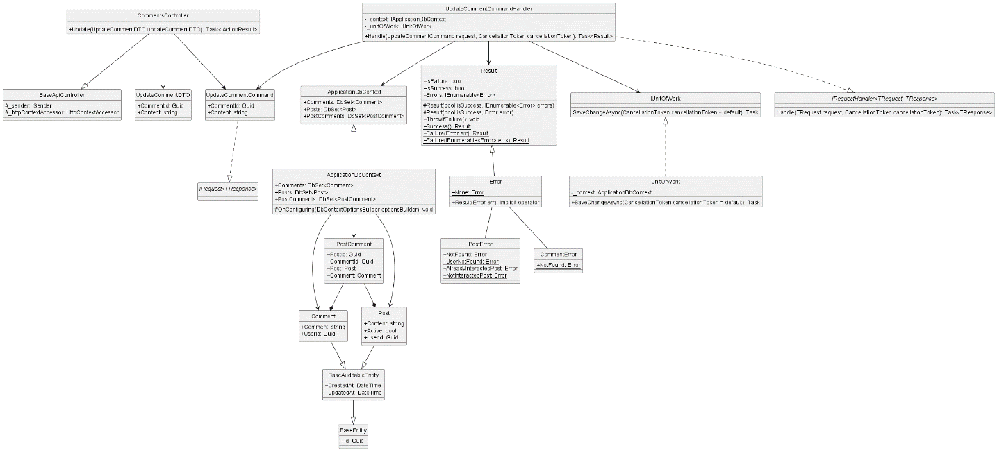

* + 1. **Create Interaction**

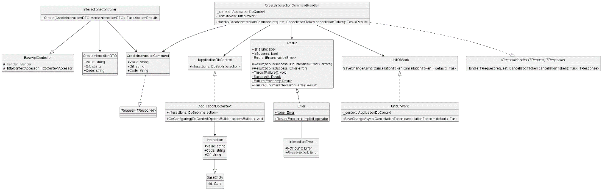

* + 1. **Delete Interaction**

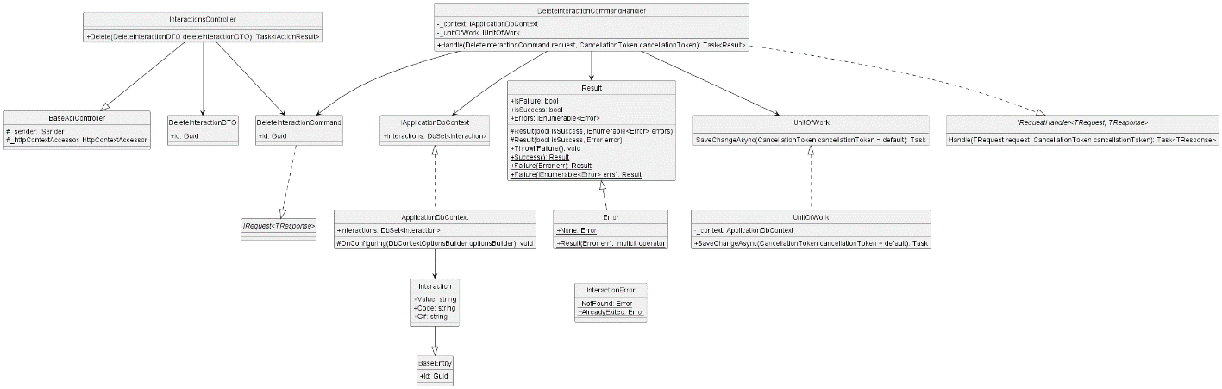

* + 1. **Get All Interaction**

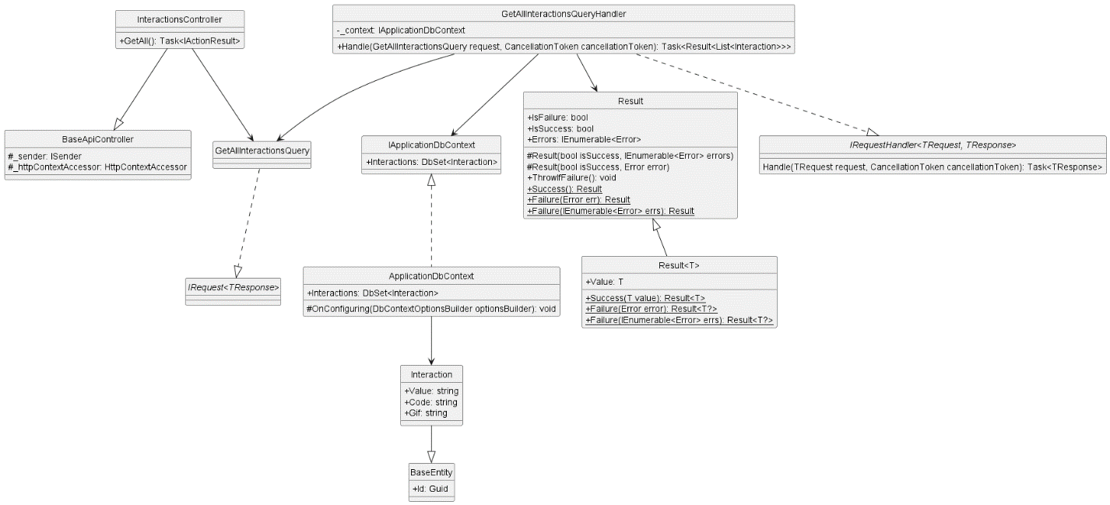

* + 1. **Update Interaction**

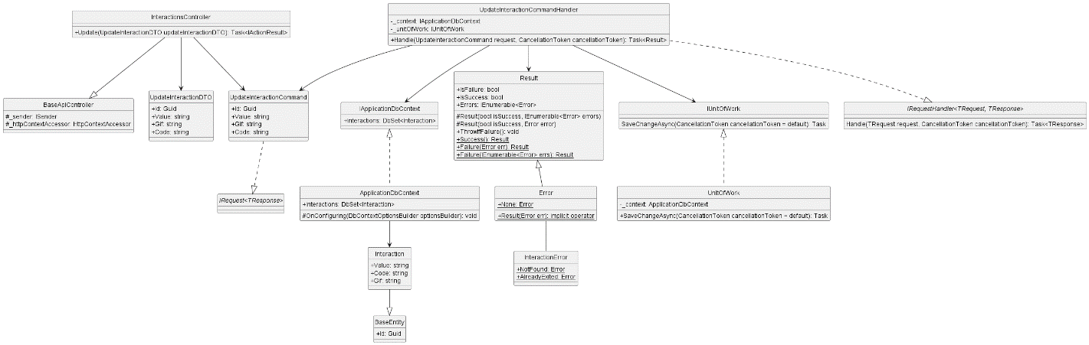

* + 1. **Create Tag**

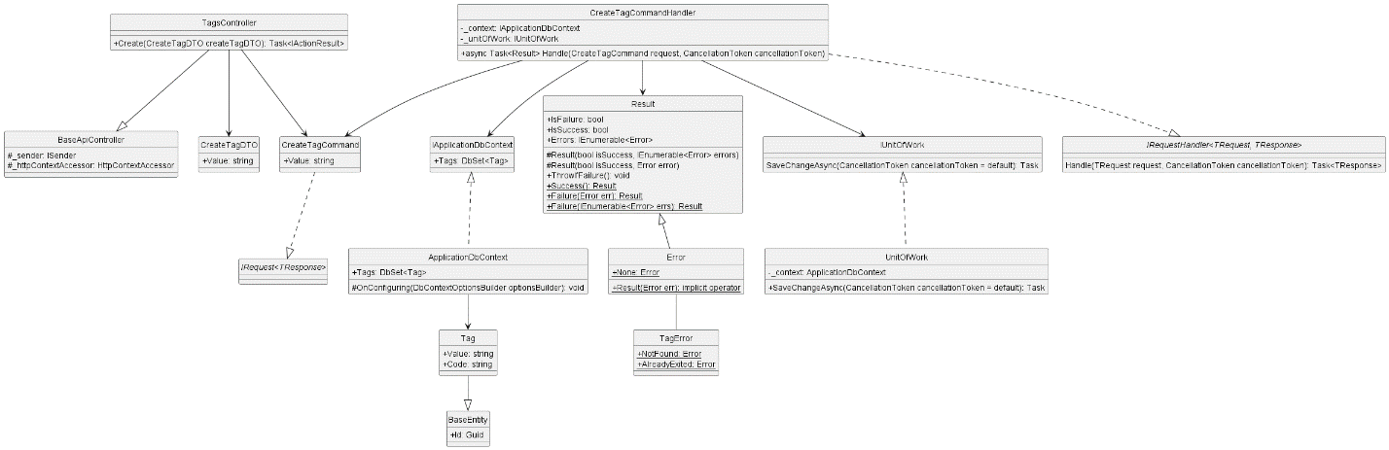

* + 1. **Delete Tag**

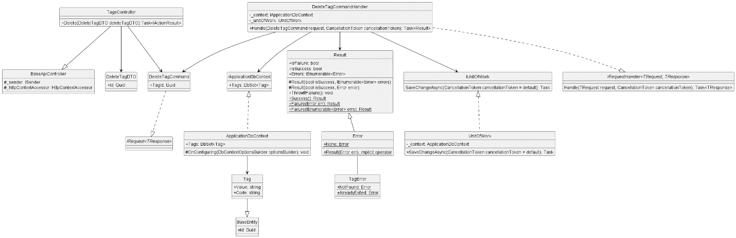

* + 1. **Get All Tag**

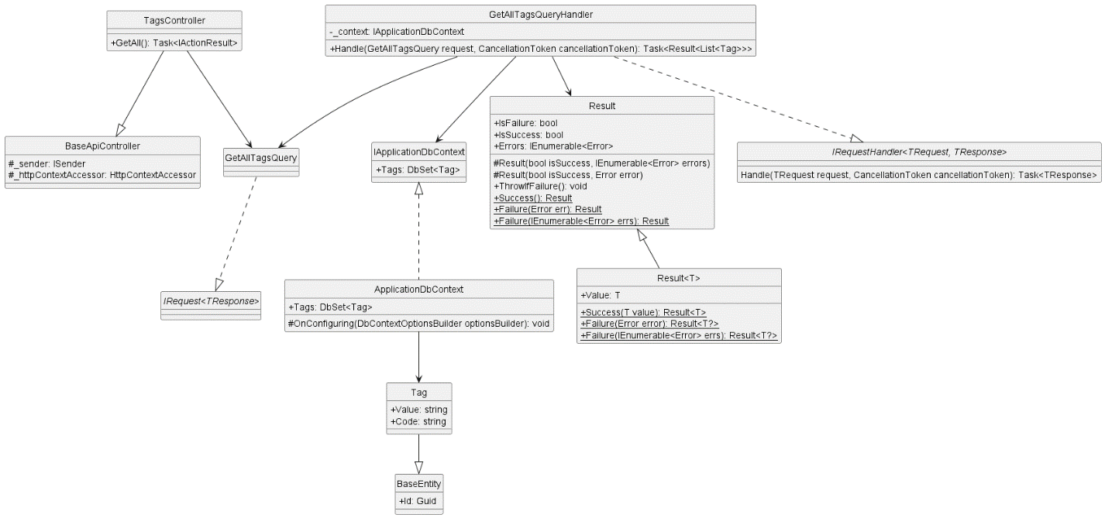

* + 1. **Update Tag**

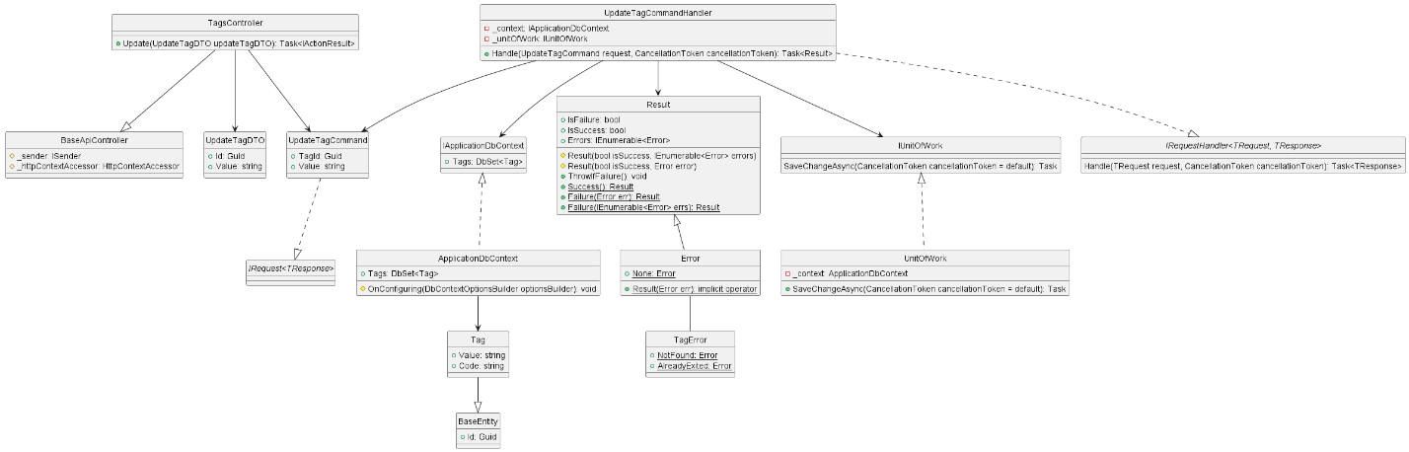

1. **Database diagram**
   1. **File Db**

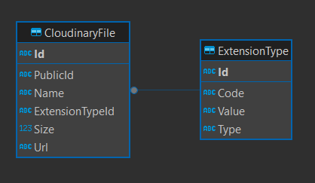

* 1. **IdentityDB**

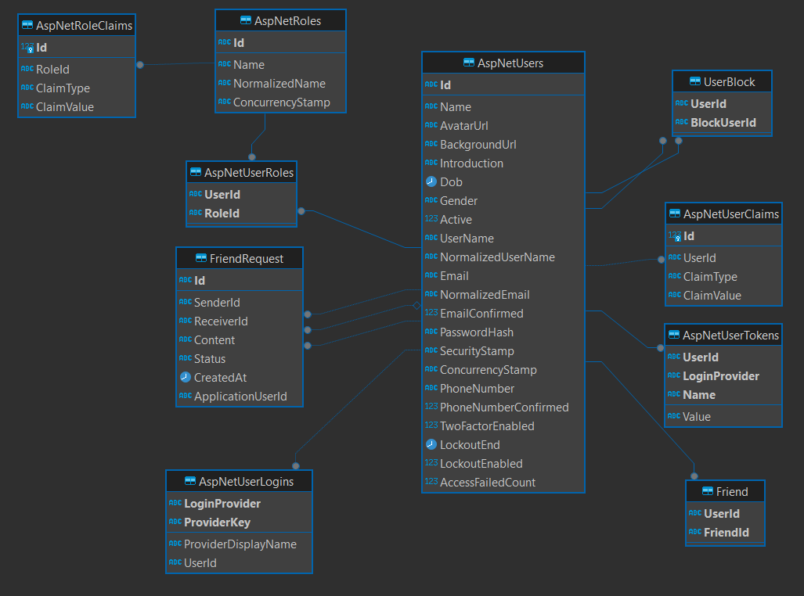

* 1. **MessageDB**

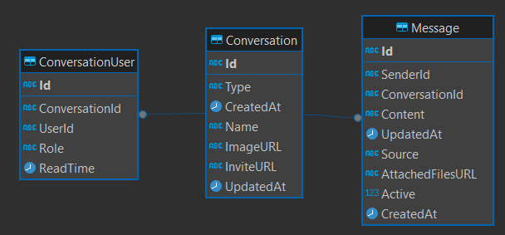

* 1. **PostDB**

